ALLERGY WORDSEARCH
Activity A34
Allergies
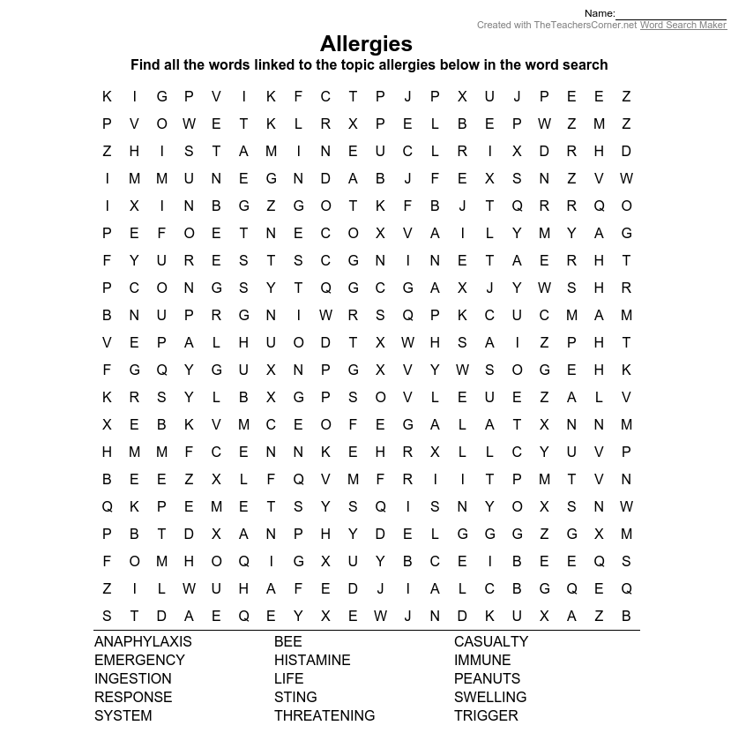
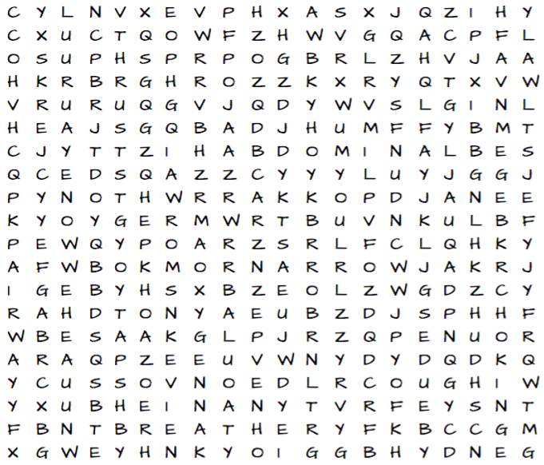

- Anaphylaxis  - Emergency  - Ingestion  - Response  - System | - Bee  - Histamine  - Life  - Sting  - Threatening | - Casualty  - Immune  - Peanuts  - Swelling  - Trigger

