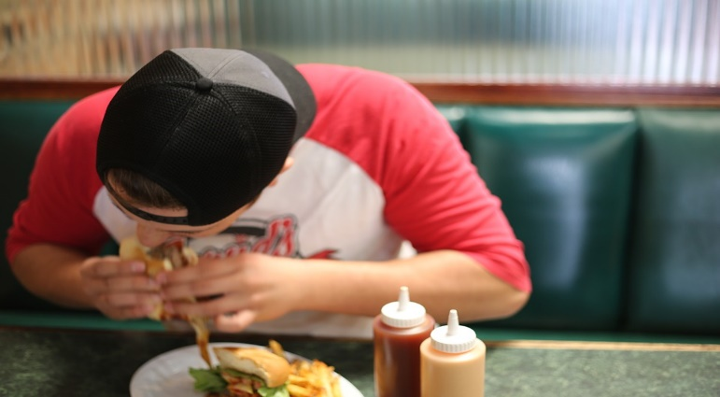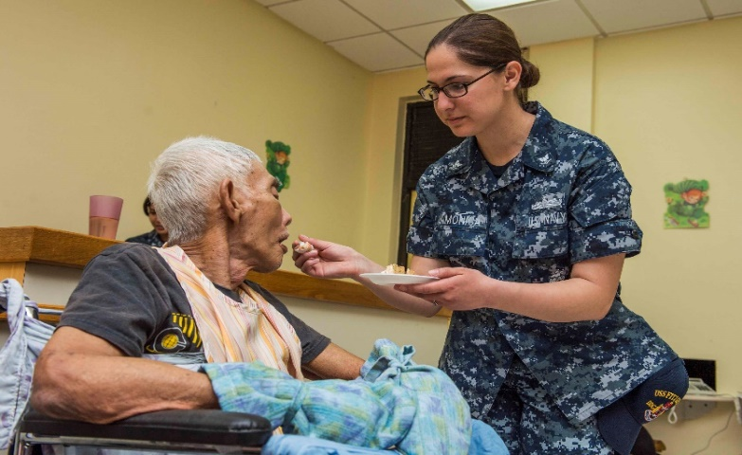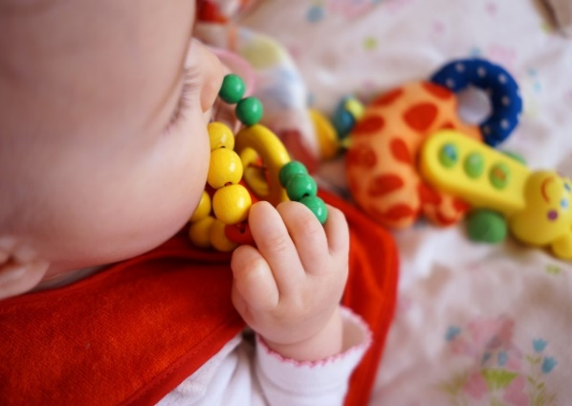 one ca

* Choking is quite a **_ _ _ _** , especially in children under the age of three
* They put objects in their **_ _ _ _ _** to explore them.
* They don’t always chew their **_ _ _ _** properly.
* They have small, **_ _ _ _ _ _**,airways.

Activity A38

Possible causes of choking for adults:

* An **_ _ _ _ _ _ _ _** reaction
* Too much **_ _ _ _** in the mouth
* Walking, talking or **_ _ _ _ _ _ _ _** whilst eating
* The elderly may find it hard to **_ _ _ _ _ _ _**
* Burns may cause tissues in the airway to **_ _ _ _ _**

Choking