CREATE THE CIRCULATORY SYSTEM
Activity A49
Chest pain
Blood travels inside blood vessels, it transports oxygen and other things our bodies need around our body. The blood vessels are called arteries which transport oxygen rich blood to the organs within the body and veins whic have the job of returning the blood to the lungs and heart after the oxygen has been used. The blood is then re oxygenated and the heart pumps it around the body again. This happens all the time without stopping, even when we are asleep.
Activity:
- Using one of the diagrams below, make your own model of the way blood travels around the human body
- Red represents the blood rich with oxygen and blue is the blood that is returning to lungs for reoxygenation
- You can choose and use materials you think will work well. Consider colour pens, wool or cut out paper etc. Maybe, cut and stick the resources provided, adding in your own arrows and colours to represent the blood flow. Be as creative as you like
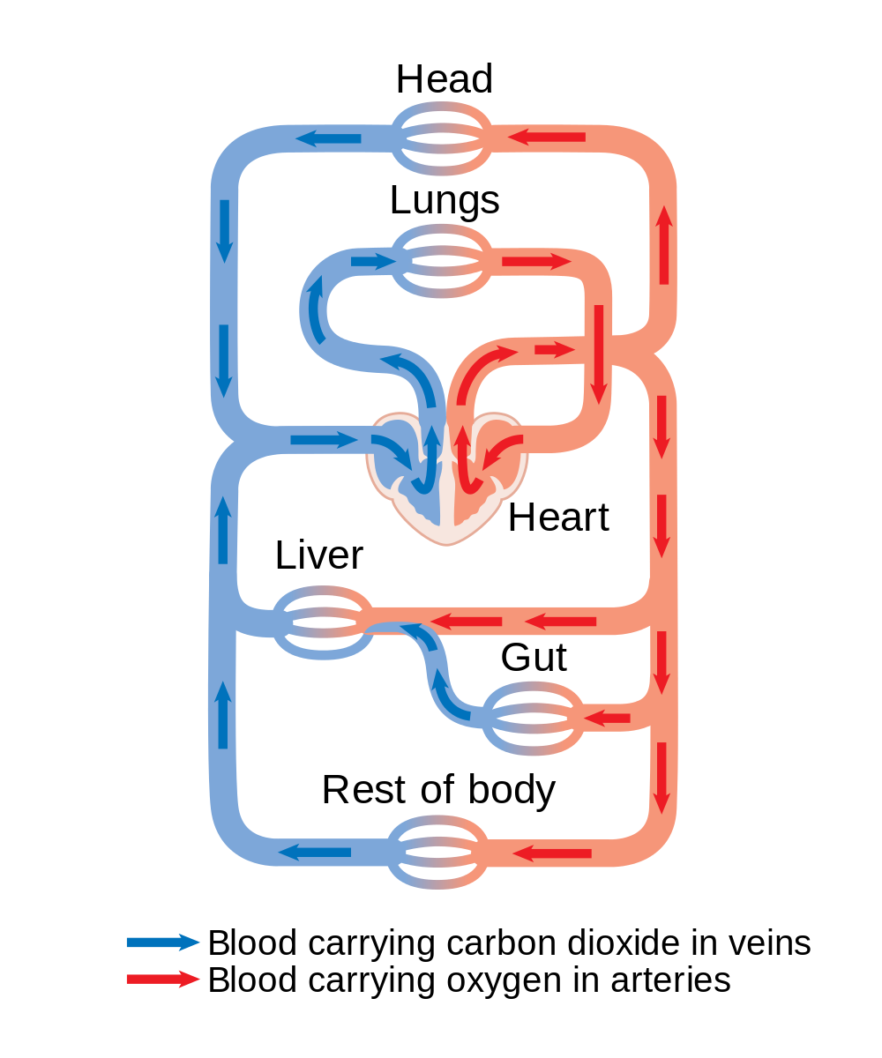
- When you are finished, compare and share with the rest of the class

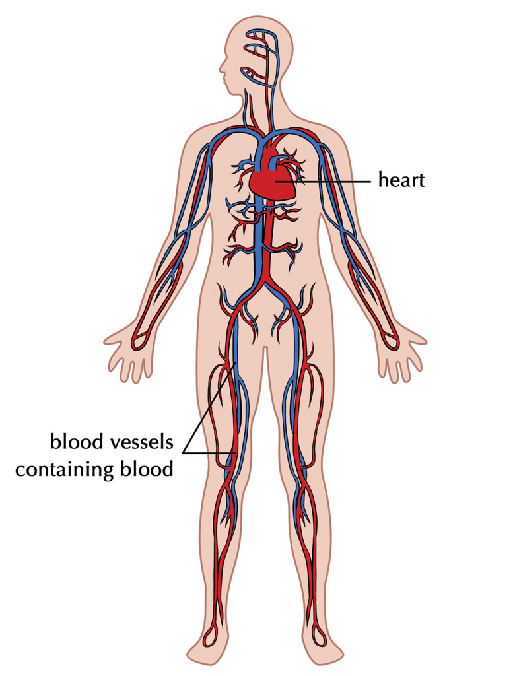

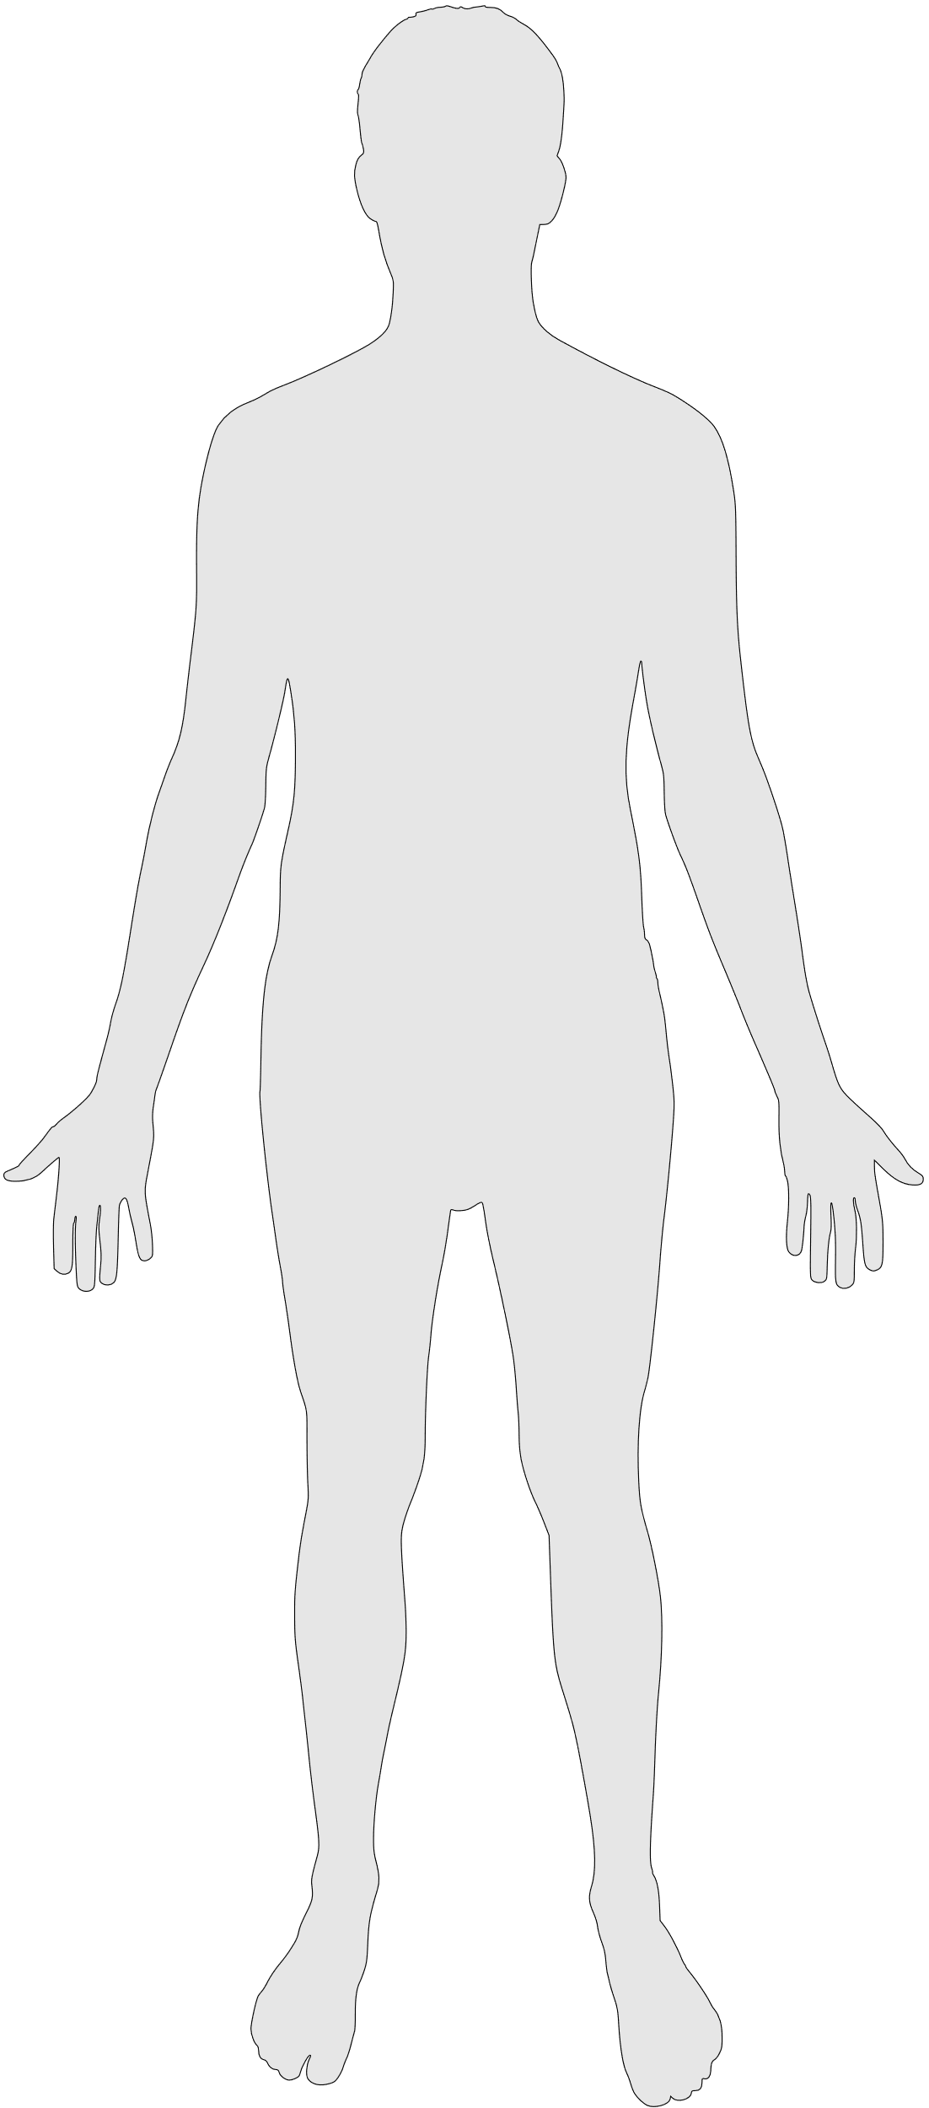
Resources

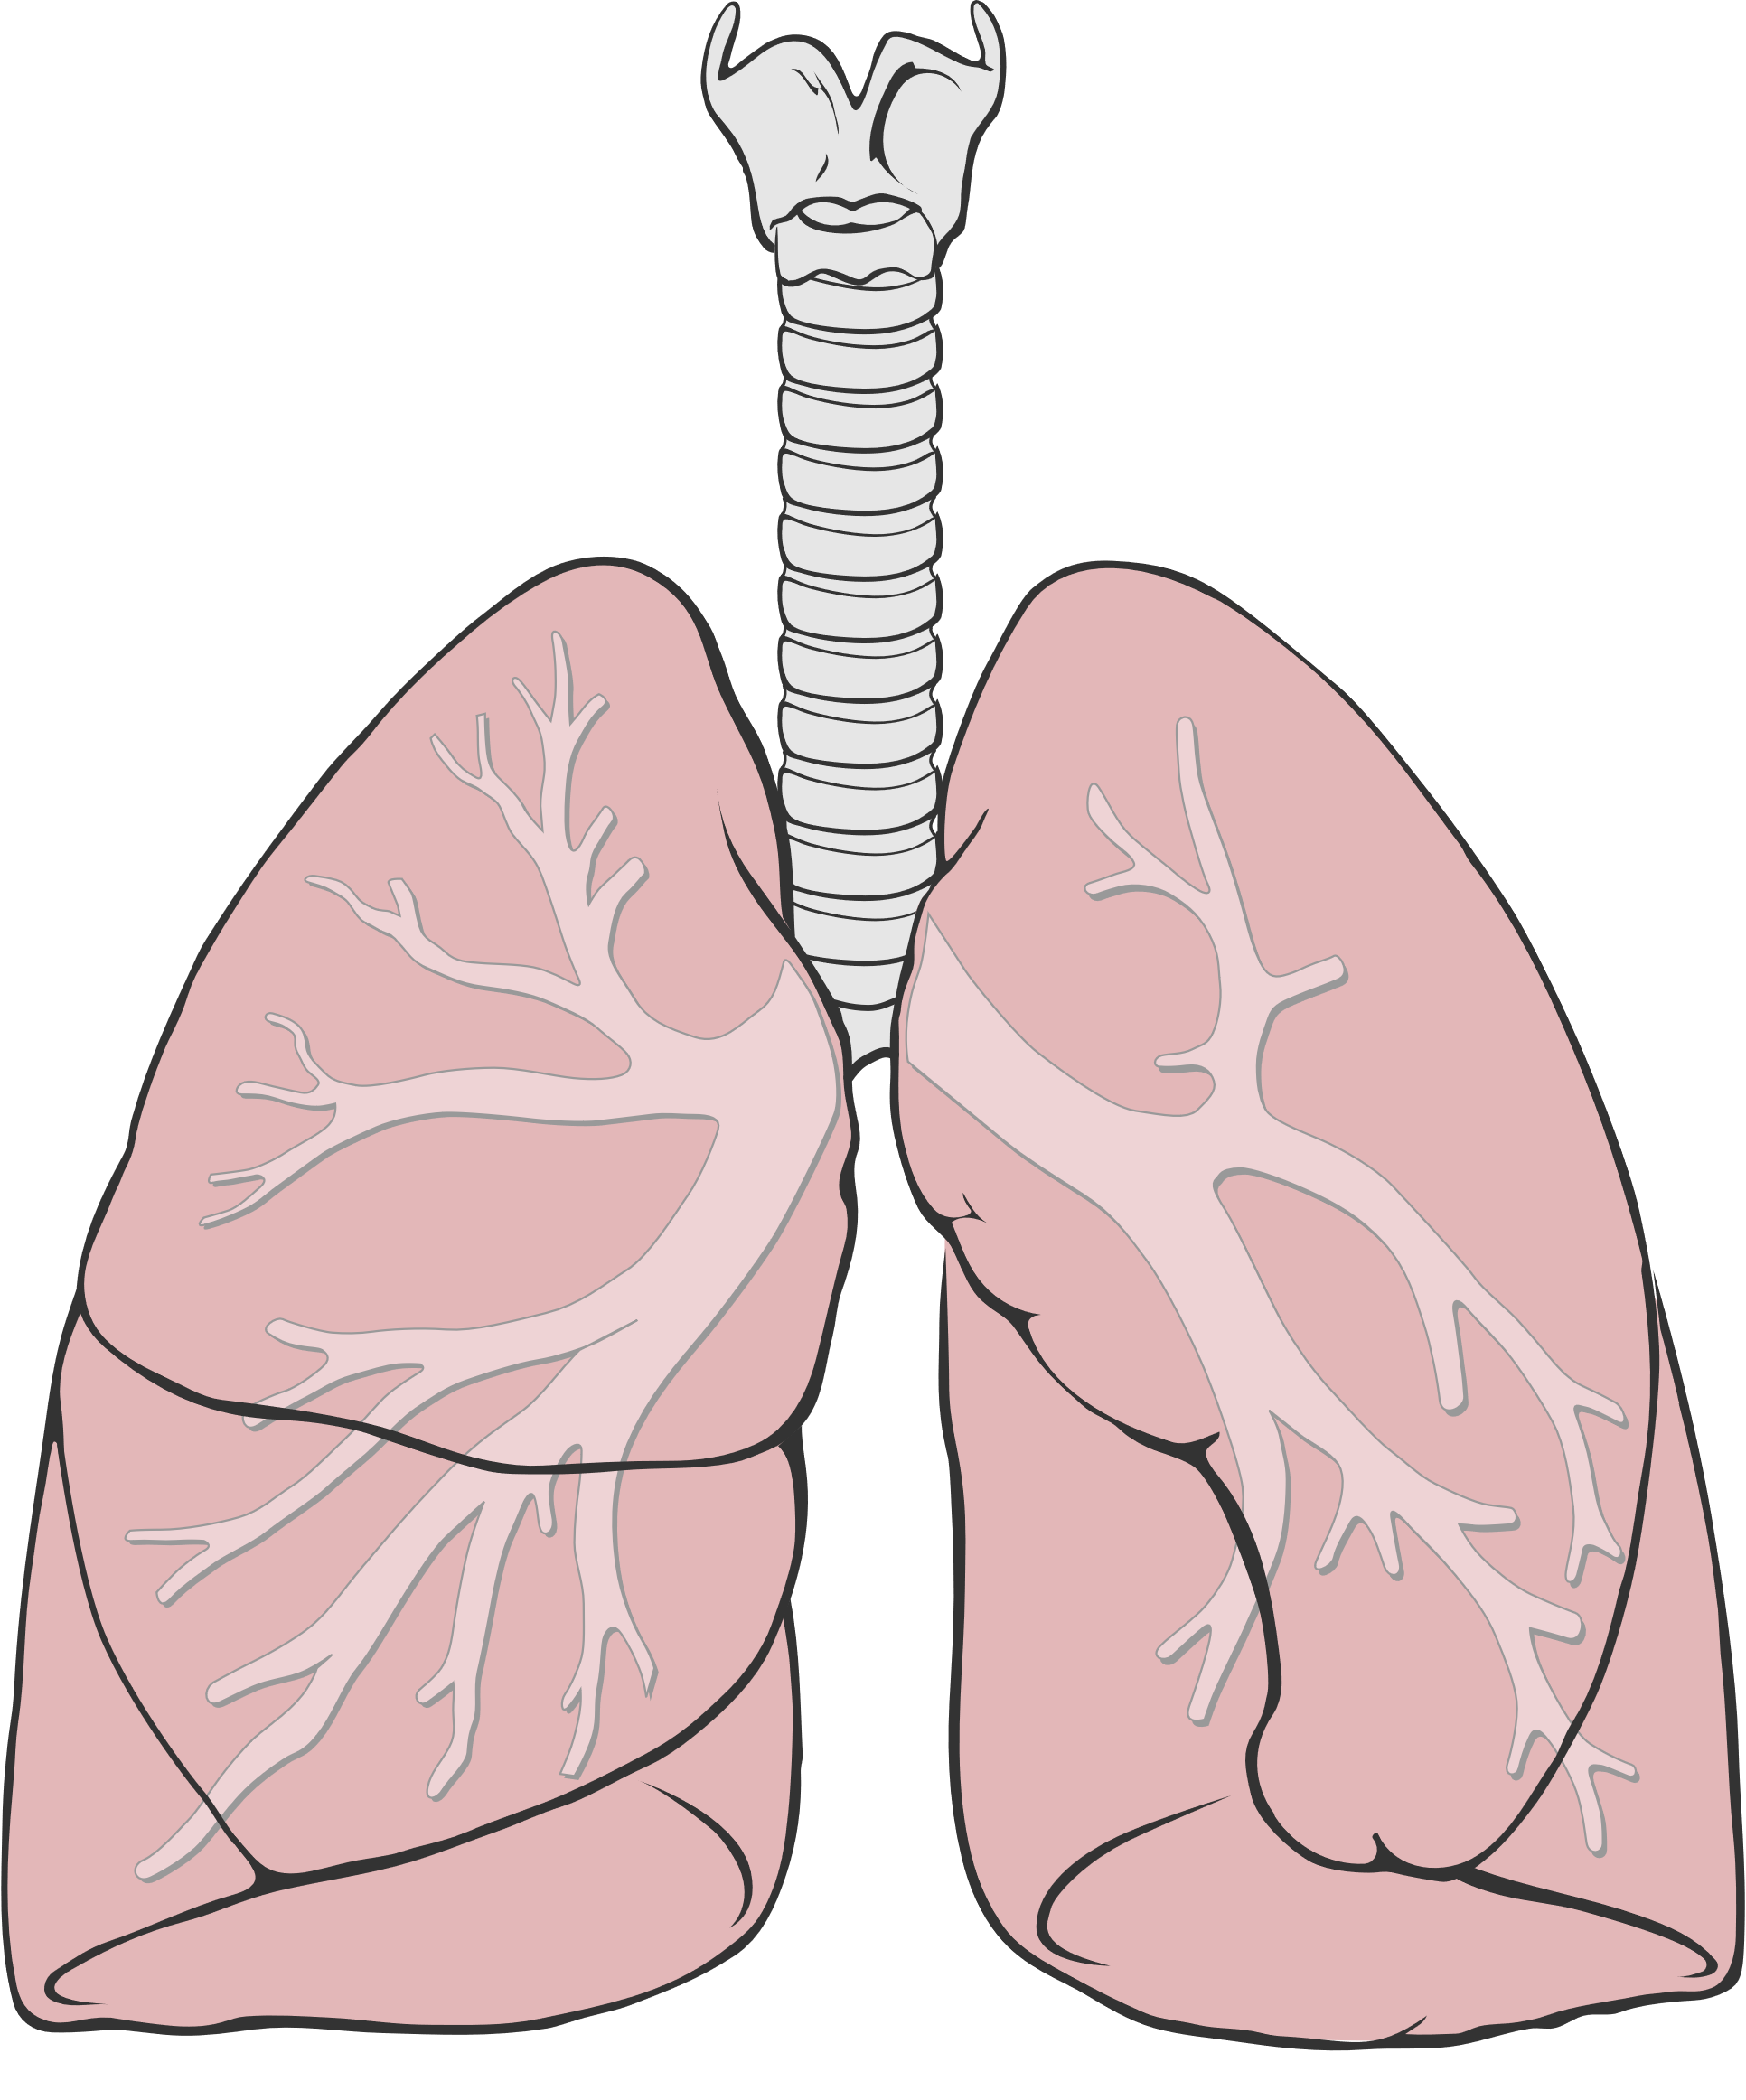 | 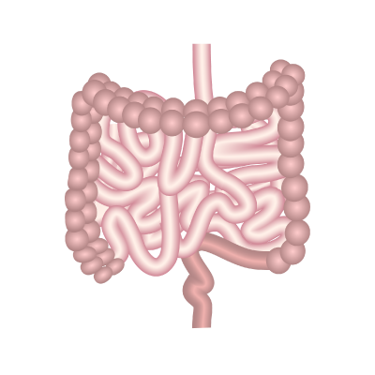
The lungs | The intestines
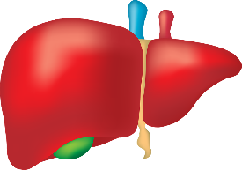 | 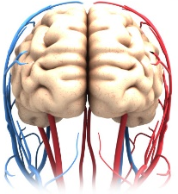
The liver | The brain
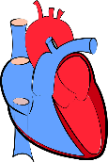
The heart

