Activity A5
Making blood
As part of our topic bleeding, you have learned about the different parts which make up our blood.
Below are instructions for a group practical session to demonstrate and illustrate the different parts and functions of blood.
What you will need:
- A jar of water that has been coloured yellow
- A jar of Cheerios breakfast cereal
- Small white marshmallows
- A salt shaker
- Red food colouring
- A spoon
- Small porcupine balls or pom poms (from a craft set)
1. What colour do you think your blood is when you cut or scrape yourself? You probably think it’s red. The correct answer is, even though blood LOOKS red, the liquid part of blood is actually yellow and is called plasma.
2. Our blood also contains salt and other chemicals. Shake some salt in to the yellow plasma.
3. There are other things floating in our blood that are very important for our bodies:
- Red blood cells (Cheerios): There are billions of red blood cells that look a little like donuts without a hole. Their job is to carry oxygen. There are so many of them floating in the plasma that it makes our blood look red. Add in the Cheerios to the plasma which represents the red blood cells and squirt in some red food colouring.
- White blood cells (marshmallows): The job of the white blood cells is to fight germs (infections) and disease. Add marshmallows to the blood to represent the white blood cells.
- Platelets (pom poms): The job of the platelets is to help us stop bleeding when we get injured. Add pom poms to the blood to represent the platelets.

4. Your finished product

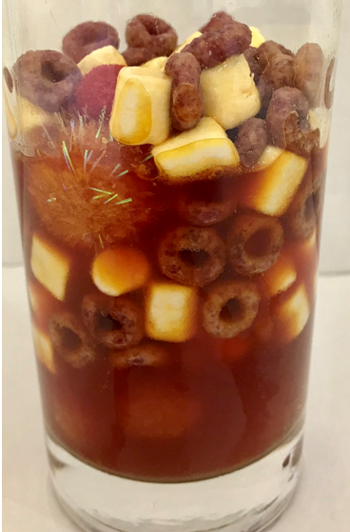

Note ratios to consider - blood contains:
- Plasma = 55%

- Red blood cells = 44%
- Platelets = 0.5%
- White blood cells= 0.5%

