CPR

Activity A15

**11**

**10**

**7**

**5**

**6**

**4**

|  |  |  |  |  |
| --- | --- | --- | --- | --- |
| **?** | **14**  **1**  **25** |  | **“HELP!”** |  |
|  | **15** | **8** | **12**  **9** | **3** |
| **5-6cm x30** |  | **13**  **X2** |  |  |

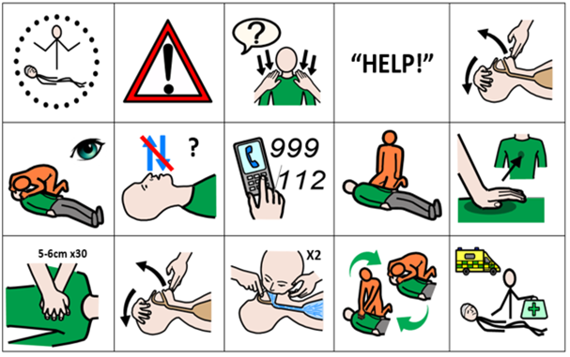

|  |  |  |  |  |  |
| --- | --- | --- | --- | --- | --- |
| **1** | You find a casualty | **6** | Check for normal breathing | **11** | Other hand on top, interlock fingers and press down 5-6cm 30 times |
| **2** | Check for danger | **7** | Breathing is not normal | **12/5** | Open the airway |
| **3** | Check for casualty response | **8** | Call for emergency help | **13** | X2 rescue breaths |
| **4** | Shout for help | **9** | Kneel by casualty | **14** | Alternate between compressions and rescue breaths |
| **5/12** | Open the airway | **10** | Heel of hand in the middle of chest | **15** | Keep going until emergency help arrives |