The human body
Activity A16
MAPPING AND RESEARCH ACTIVITY
Activity:
- This activity will provide you with a basic understanding of human anatomy and the roles the different organs and body parts play in keeping us alive and healthy.
- Your teacher will be giving you instructions on what you need to do to complete this activity, so, listen carefully
What you will need:
- the resources provided by your teacher
- scissors
- glue
- colouring pencils
- a large piece of paper

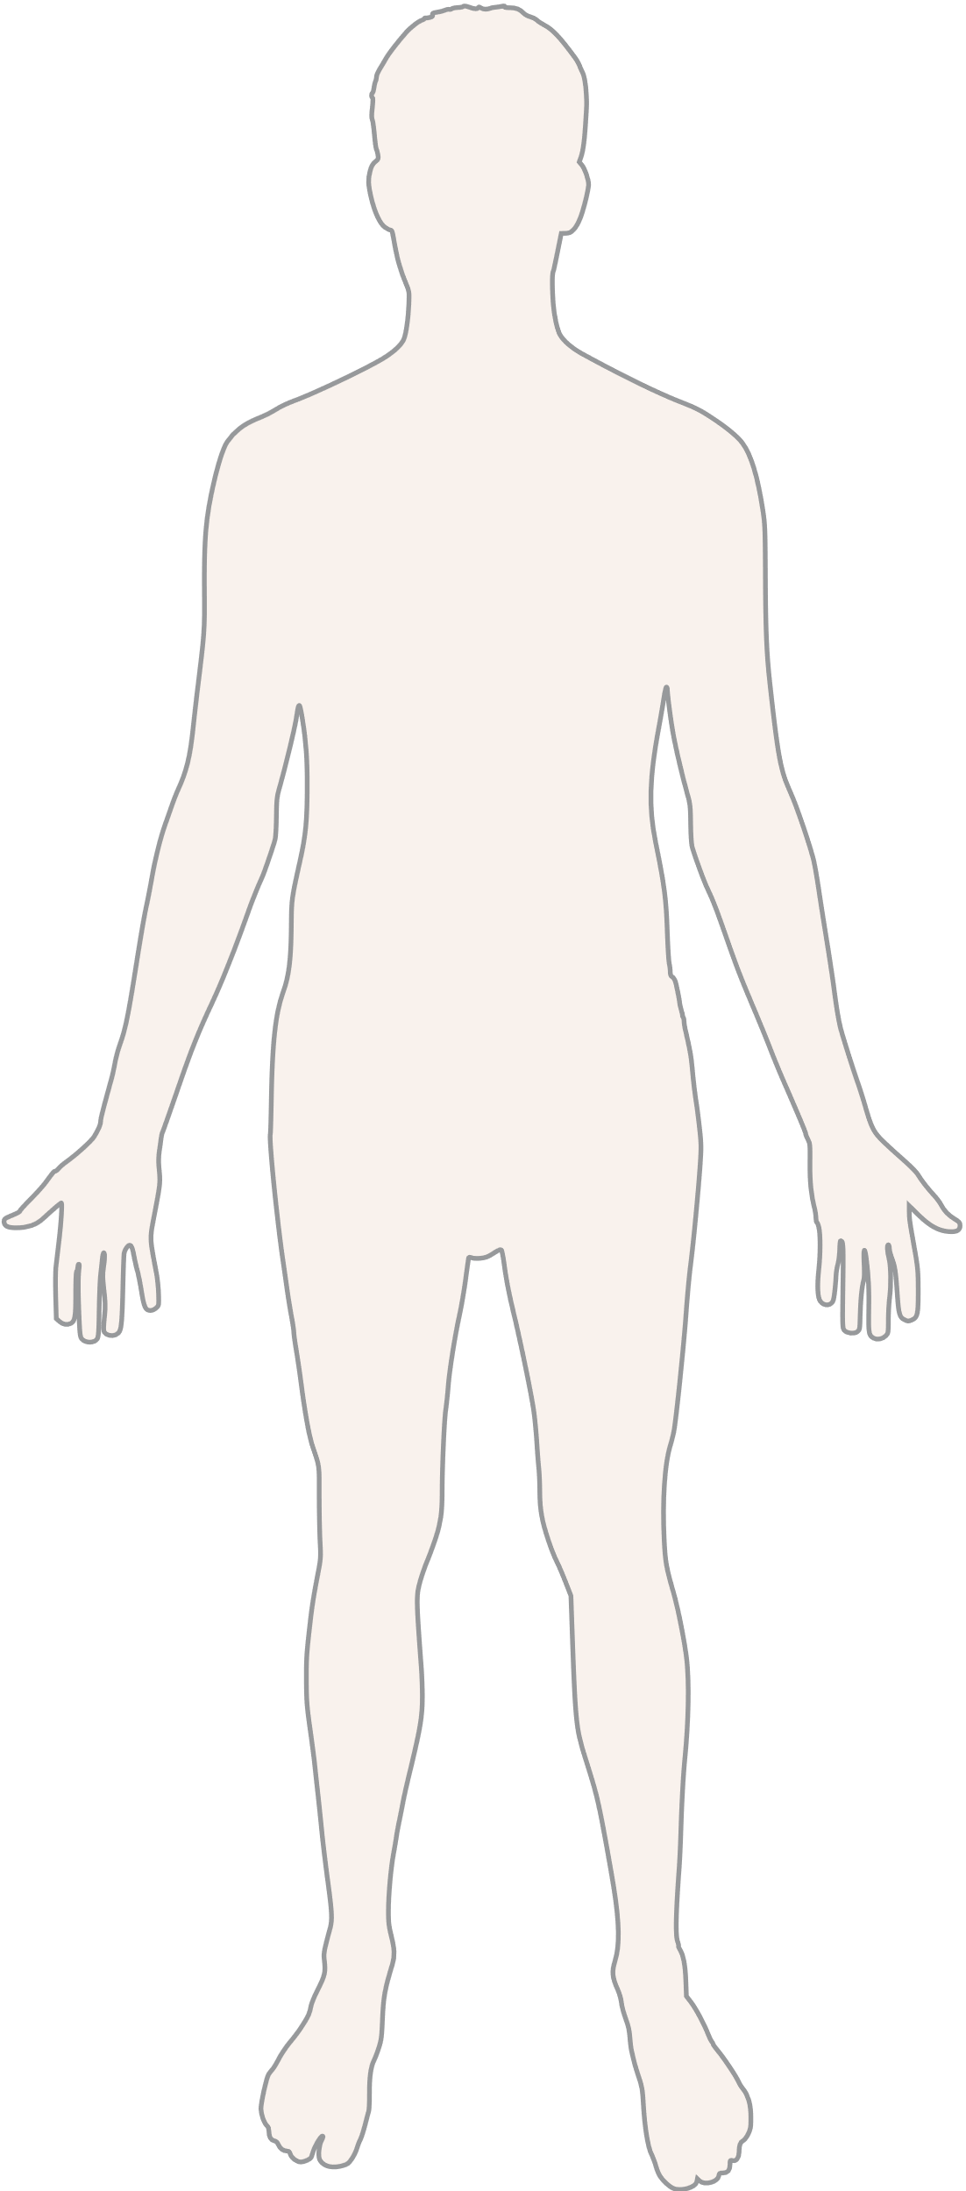
Resource 1

