Bleeding and shock

Activity A43

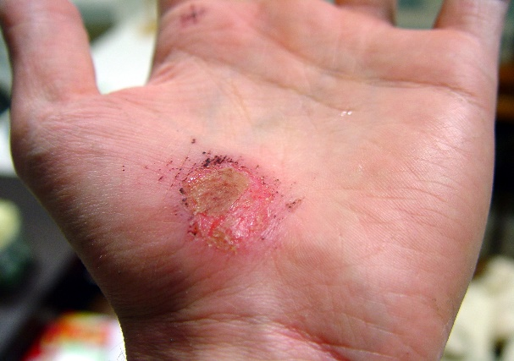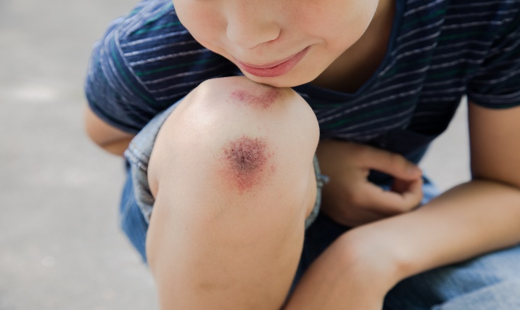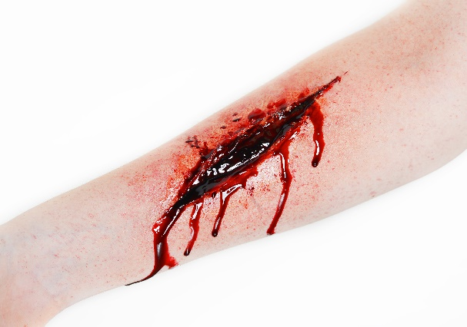**TYPES OF WOUNDS**

* **Abrasion**(graze)
* **Incised wound**(caused by a sharp edge e.g. razor)
* **Laceration**(blunt or ripping)
* **Puncture**(e.g. standing on a nail)
* **Stab wound**(deep incision usually caused by a knife)
* **Contusion**(bruise)

