Activity A48

The heart

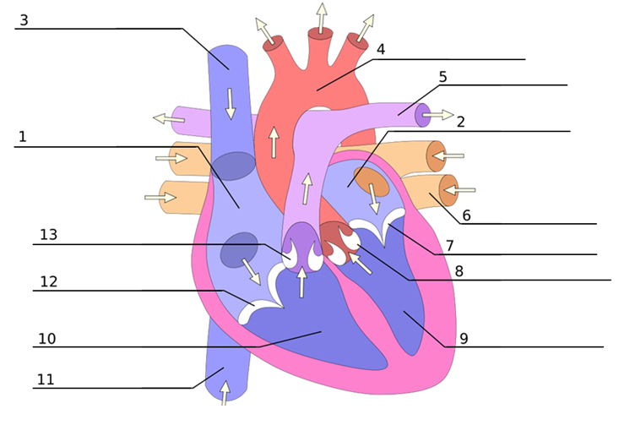

ANSWERS:
1. Right Atrium
2. Left Atrium
3. Superior vena cava
4. Aorta
5. Pulmonary artery
6. Pulmonary vein
7. Mitral valve
8. Aortic valve
9. Left ventricle
10. Right Ventricle
11. Inferior vena cava
12. Tricuspid valve
13. Pulmonary valve

