RESEARCH TASK – THE HEART
Activity A48
Chest pain
- Label the key components of the heart which are numbered below. You may need to do some research to help you.
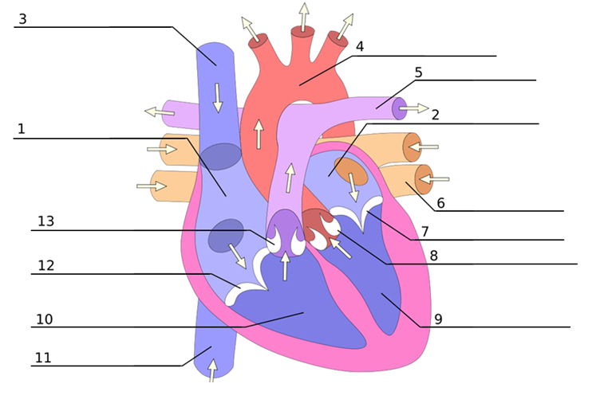

B) Find some information and facts relating to the heart and its function in the human body. You may want to include some of the following ideas: the heart and its function within the body, statistics relating to heart disease within the UK, recommendation and advice for preventing heart disease.

