- Trachea  - Left lung  - Diaphragm  - Alveoli  - Nose and mouth | - Right lung  - Primary bronchi  - Larynx  - Secondary bronchi  - Oesophagus
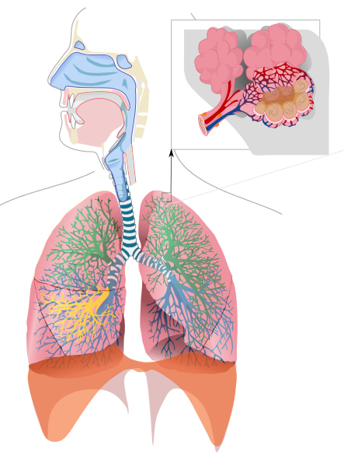
Labelling the Respiratory System
Activity A42
Choking

