CREATE THE RESPIRATORY SYSTEM
Activity A29
Asthma
The respiratory system contains the organs we need to get oxygen into our bodies and remove the waster carbon dioxide. Air is taken in via the nose and the mouth into the trachea and bronchi to reach the lungs. In the lung oxygen is diffused from the air into the blood and carbon dioxide is diffused from the blood into the air.
The main parts of the respiratory system are listed below.
Working in pairs, use the resources available to create a diagram like the one below:
What you will need (or anything you think will work well)
- large roll of paper (wallpaper works well)
- marker pens
- white card
- colouring pens/paint
- play dough
- print of out the respiratory system
What to do:
- Firstly, one person should lie on the wallpaper (use the back of the wallpaper if it is patterned, coloured or difficult to draw upon)
- When they are in position, draw around them, so that there is an outline of their body, like the body outline in the diagram
- Once the outline is complete use a pencil to mark where the main parts of the system should be
Be sure to mark on the body, the following:
- left lung  - right lung  - nose  - nasal cavity | - mouth  - larynx  - trachea  - bronchus | - epiglottis  - ribs  - diaphragm

Now:
- Using pens, paints or other materials you think would work well, create the diagram below
- For example, you could use stiff card to make the ribs that lie over the lungs. You could use plasticine to mould the shape of the trachea. (You can even draw and colour in the different parts if you do not have many materials)
- Just have a go and use different materials to make a model of the respiratory system
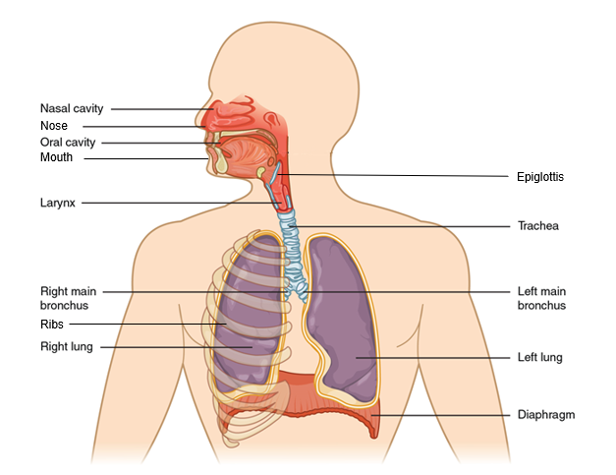

When you are finished, compare and share with the rest of the class.
S&C - Can you research and then show the rest of the class how air travels down into the body and what happens when we breathe?

