Activity A16
The human body
MAPPING AND RESEARCH ACTIVITY
To begin:
- Students can work alone, in pairs or small groups
- Children should then draw an outline of the human body on a large piece of paper or use the outline provided in the resources

Activity
- This activity will provide a basic overview of human anatomy and the roles the different organs and body parts play in keeping us alive and healthy
- There are a number of options you can choose to do within this activity. Choose options based on the age/stage of studying. Then, copy the resources and verbally instruct the class on how they should complete the activity

- Using labelled body parts in resource 2, decide where the body parts would be situated within our bodies. Cut out the human outline and body parts and stick them to the larger piece of paper, showing where our organs are situated.

- Using images that are not labelled in resource 3, students must identify the different parts of the body before cutting and sticking them onto the human outline on the larger piece of paper.
- After completing one of the activities above, students can then be asked to find out the function/some facts on each of the body parts. You can
choose to stick resource 4 around the outline or keep them like a pack of revision cards/make a poster with them.
- Using images as a visual reference, students can be asked to DRAW the parts of the body using coloured pencils instead of just sticking images onto the outline. An extension of this can include writing a short piece around each area they have drawn which includes key functions and facts.

TIP: Researched information could be:
- It is located…
- It is about the size of…
- Its job is to…
- Without it, our bodies would not…
Resource 1
- The children have been provided with the outline of the human body along with their introduction to the activity.

Resource 2 – labelled body part
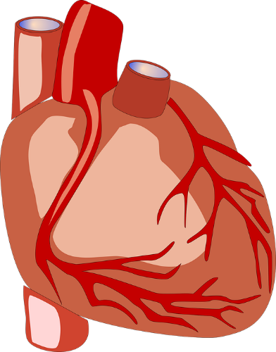
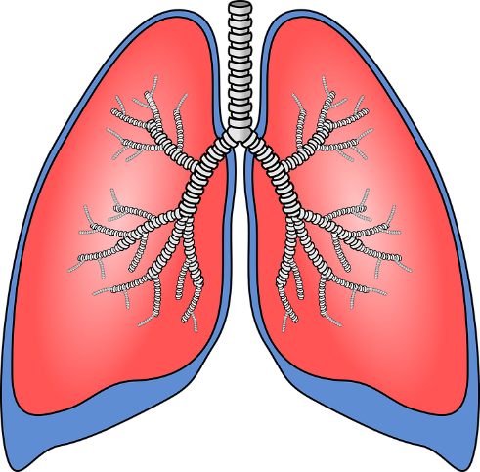
This is the heart.
These are the lungs.
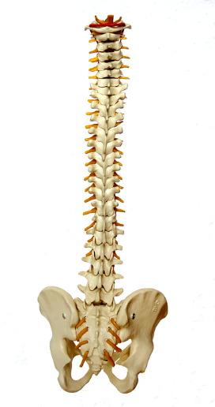
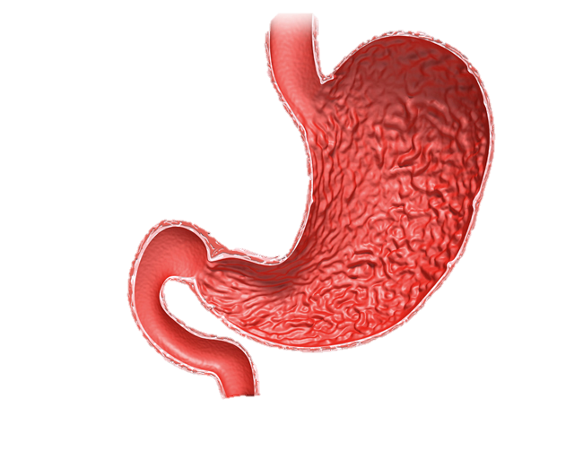
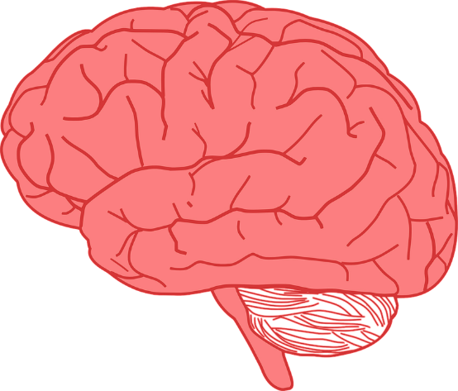
This is the trachea.
This is the spine.
This is the stomach
This is the brain.
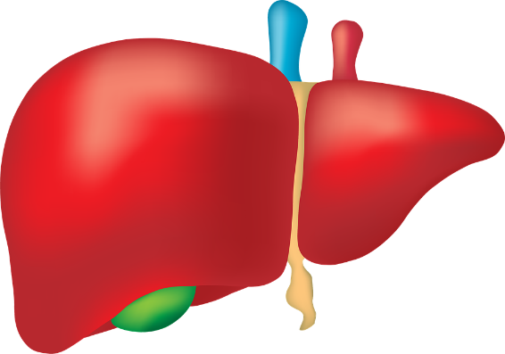
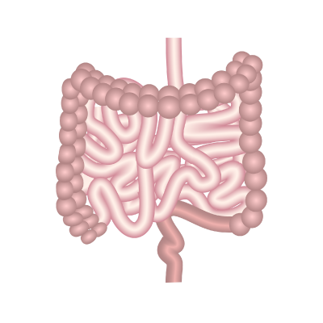
This is the liver.
These are the intestines.

Resource 3 – Unlabelled body parts
This is the
This is the
This is the
These are the
This is the

This is the
These are the
This is the

Resource 4
The heart
What I have learnt about the heart:
The lungs
What I have learnt about the lungs:

The stomach
What I have learnt about the stomach:
The brain
What I have learnt about the brain:

The spine
What I have learnt about the spine:
The trachea
What I have learnt about the trachea:
The Intestines
What I have learnt about the intestines:
The liver
What I have learnt about the liver:

