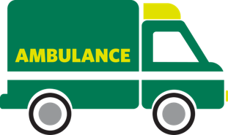
WHEN THINGS GO WRONG
Basic life support
Activity A12
Breathing (air in and out via the lungs):
1.
2.

Circulation (blood travelling around the body):
1.
2.
Think of two reasons someone could have a breathing or circulation emergency.

