Make a stethoscope

Activity A11

Stethoscopes are mostly used to listen to a person’s heart. We can easily make a very basic stethoscope.

**What you will need:**

* Funnel
* Gaffer tape
* Cardboard tube

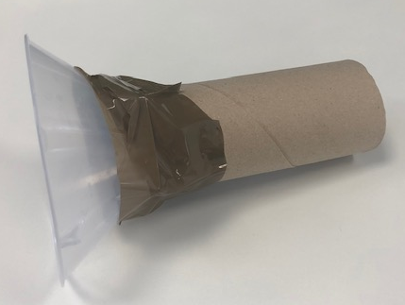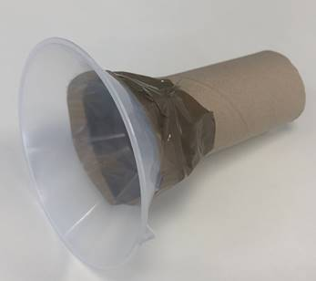

**Extension:**

* How could you make the stethoscope better? What if you used a hose with a funnel at each end? Or different sized funnels? Which do you think would work best?
* What happens to your heart rate if you jump up and down for a few minutes?

**Explanation:**

* Stethoscopes used by healthcare professionals consist of a chest piece, rubber tubes and earpieces. The chest piece consists of a diaphragm and bell which amplifies sounds so that the healthcare professional can hear them.

**Method:**

1. Attach the funnel to the cardboard tube using gaffer tape.
2. Place on a friend’s chest and listen to their heart beat.
3. Can you count how many times the heart beats in one minute?