CREATE THE CIRCULATORY SYSTEM
Activity A38
Bleeding
Blood carries oxygen and other things our bodies need, around our body inside blood vessels. Some vessels take blood with oxygen to our organs that need it in order to work properly. Other blood vessels have the job of returning the blood to the lungs and heart after the oxygen has been used. The blood is then re oxygenated and the heart pumps it around the body again. This happens all the time without stopping, even when we are asleep,
Activity:
- Using one of the diagrams below, make your own model of the way blood travels around the human body
- Red represents the blood rich with oxygen and blue represents the blood that is returning to the lungs for reoxygenation
- You can choose and use any materials you think will work well. Consider colour pens, wool or cut out paper etc. Make them as informative and engaging as you can
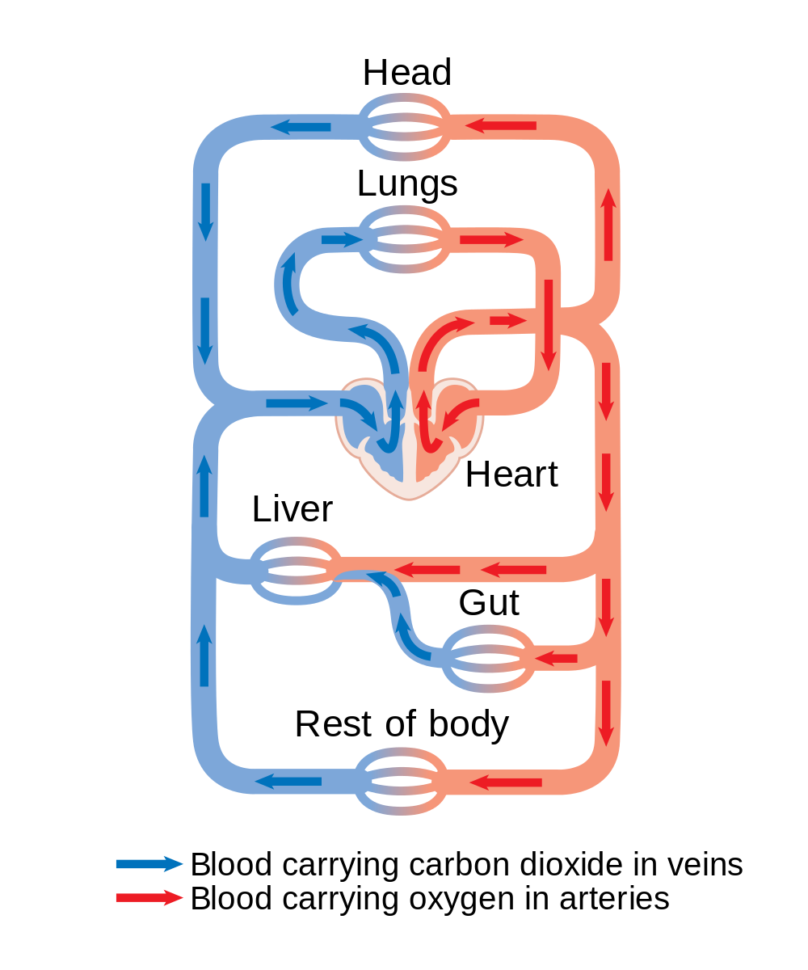
- When you are finished, compare and share with the rest of the class

