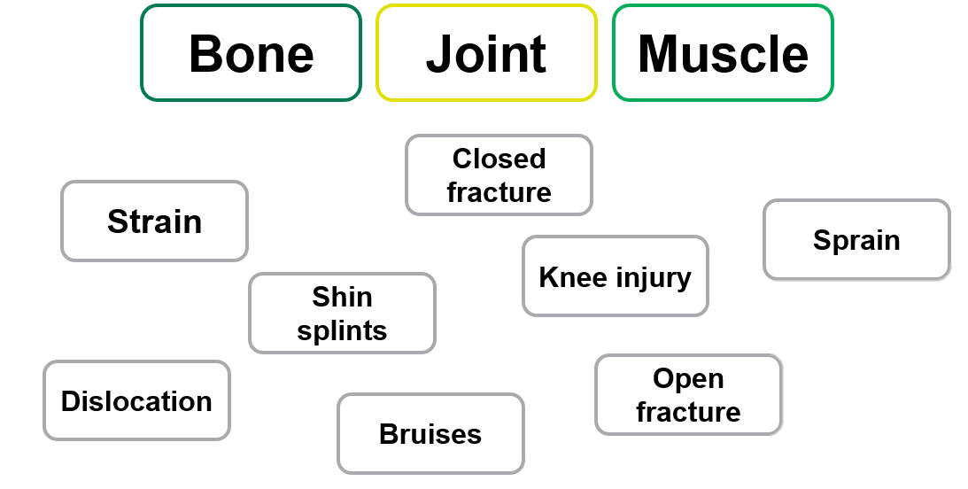
ca
Draw a line to match the following:
Activity A46
Bone, muscle and joints

